d)

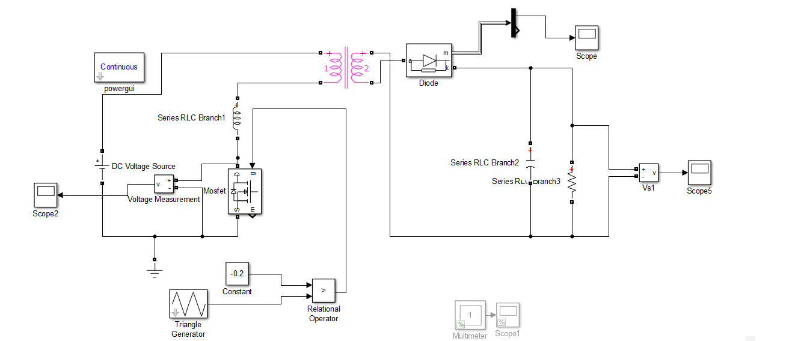

Figure 1: Flyback Converter with Leakage Inductance

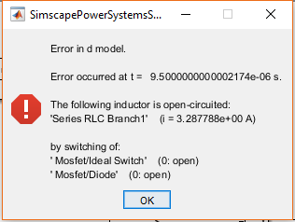

Figure 2: Error Caused by Discontinuous Leakage Inductor Current

Leakage inductor current has to be continuous. However, switching causes discontinuity in the current, which results in error in **Figure 2**. In real, abrupt change in the leakage inductance current cause high voltage difference across the terminals of the switch. Therefore, it is necessary to implement a snubber across the terminals of the primary winding to protect the switch. The snubber will provide a path to current to flow continuously. The snubber seen in **Figure 3** helps the switch voltage to stay limited.

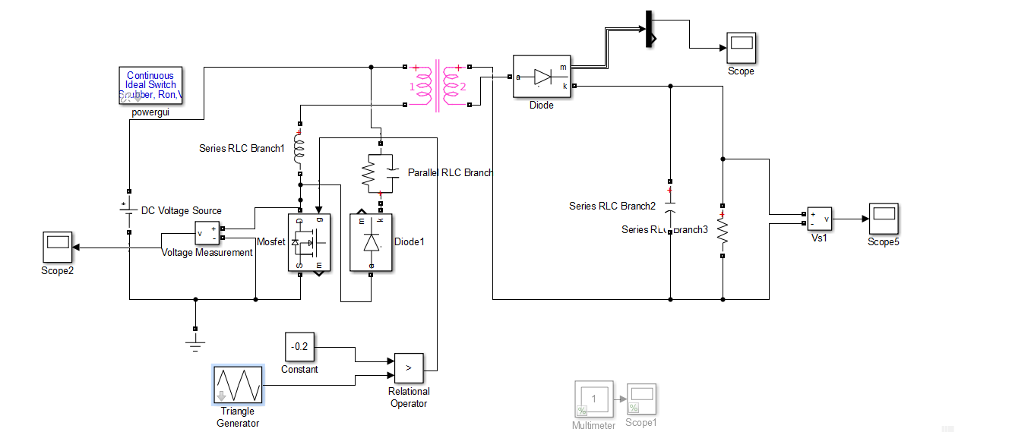

Figure 3: Flyback Converter with Leakage Inductance and Snubber

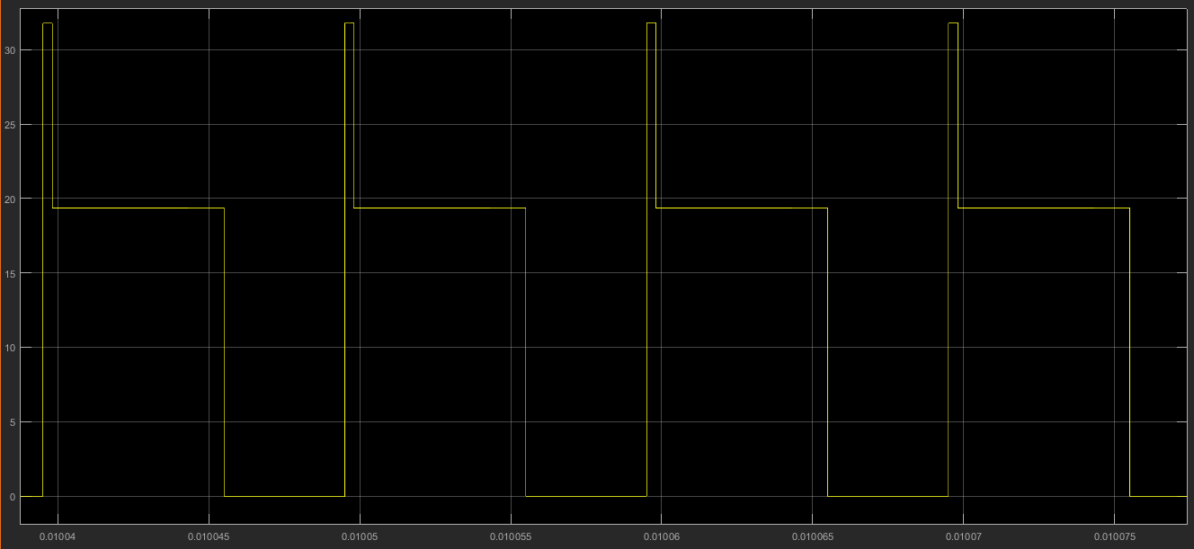

Figure 4: Switch Voltage